Cladrastis lutea - (F.Michx.)K.Koch.
Common Name | Yellow Wood, Virgilia, American Yellow Wood
Family | Fabaceae or Leguminosae
USDA hardiness | 4-8
Known Hazards | None known
Habitats | Woods in rich well-drained limestone soils, in river valleys, slopes, ridges and the borders of streams
Native Range | Southeastern N. America - Appalachian mountains, mainly in North Carolina and Tennessee.
Physical Characteristics
Yellowwood is so-named because the freshly-cut heartwood is a muted to brilliant yellow color, and the wood is known to yield a yellow dye . This native, deciduous tree makes a very striking specimen or shade tree, reaches 30 to 50, rarely 75 feet in height, with a broad, rounded canopy, and has a vase-shaped, moderately dense silhouette. Smooth, grey to brown bark, bright green, pinnately compound, 8 to 12-inch-long leaflets, and a strikingly beautiful display of white, fragrant blossoms make Yellowwood a wonderful choice for multiple landscape uses.
Bloom Color: White. Main Bloom Time: Early summer, Late summer, Midsummer. Form: Rounded, Vase.
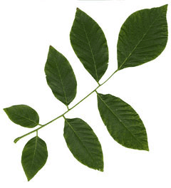
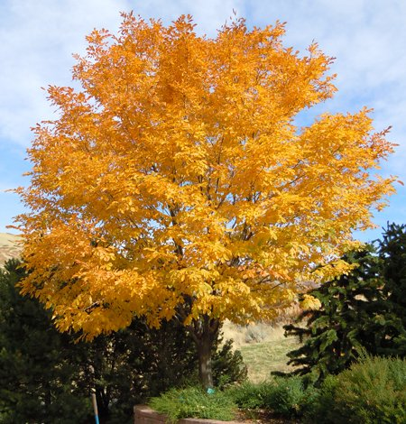
Halesia carolina - L.
Common Name | Silver-Bell Tree, Carolina silverbell, Mountain silverbell
Family | Styracaceae
USDA hardiness | 5-8
Habitats | Moist woods along the sides of streams in the mountains.
Native Range | Southeastern N. America - Virginia to Florida, west to Oklahoma.
A Southeast U.S. native, small understory tree with a broad, rounded crown or a large shrub. In the wild, Carolina silverbell typically does not exceed 35' in height (though specimens have been found in the 80-100' range), and is frequently shrubby in habit. Features drooping clusters (usually 2-5 flowers each) of bell-shaped, white flowers (1/2") which appear in April shortly before or simultaneous to the point when the leaves emerge. Four-winged, brownish, nut-like fruits appear in the fall and often persist well into the winter. Dull, finely toothed, dark yellowish-green, ovate-oblong leaves (2-5" long) turn a somewhat attractive yellow in fall, but may drop rather early. Synonymous with Halesia tetraptera (tetraptera meaning four-winged).
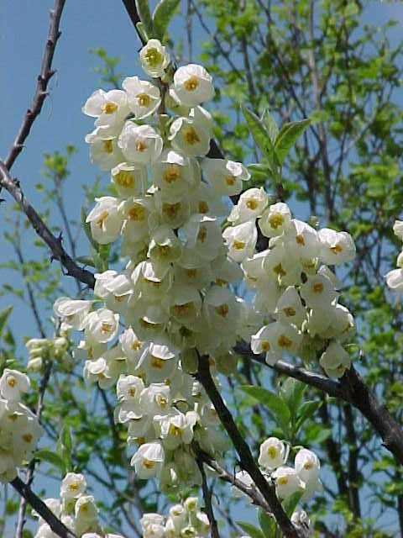
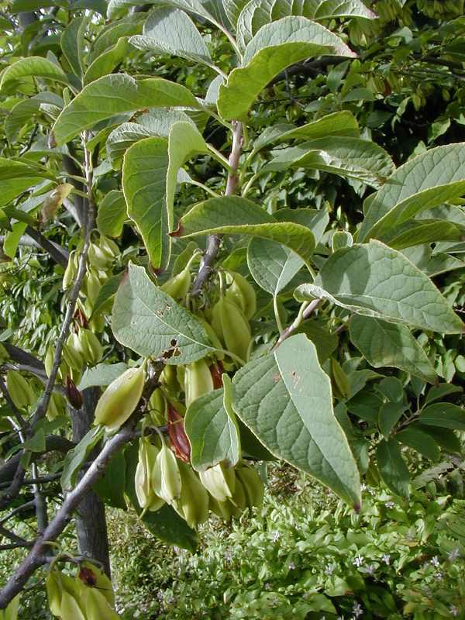

Pinus taeda
Common Name | Loblolly Pine
Family | Pinaceae
USDA hardiness | 6-9
Habitats | Flatlands or rolling hills from sea level to 3000 ft. Found on a variety of soil types from low poorly drained areas to well drained soils, but usually on poor upland soils.
Native Range | South-eastern N. America - New Jersey to Florida and Texas.

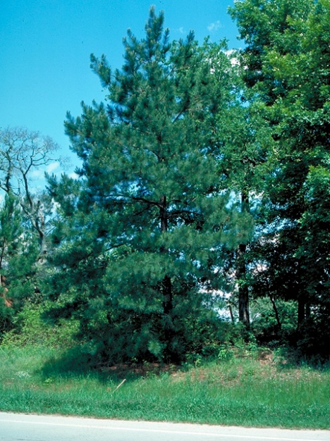
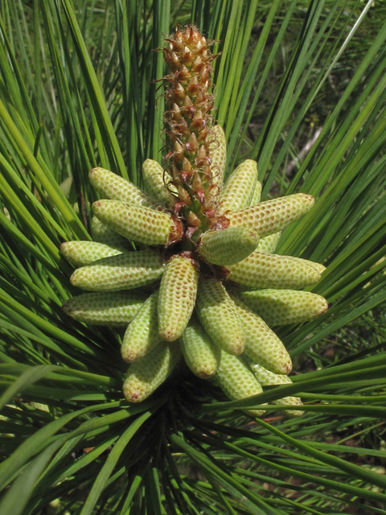
Loblolly pine is a fast-growing, medium to tall conifer that is common to the southeastern U. S. where it typically grows from sea level to 2400’ in a variety of conditions ranging from poorly-drained low wet areas, bottomland forests and flatlands to well-drained upland soils. It is native from southern New Jersey to Florida and west to eastern Texas. It sometimes grows in pure stands. It typically grows to 40-50’ in cultivation, but may reach 90’ tall or more in the wild. This tree is particularly noted for its straight trunk. It loses its lower branches as it matures, gradually developing a dense oval-rounded crown. Dark yellow-green needles (5-10” long) in bundles of three (infrequently in bundles of two) are finely-toothed, stiff and slender. Stalkless, oval-cylindrical cones (3-6” long) with sharply-spined scales appear in groups of 2-5. Scaly gray bark develops furrows with age. Taeda comes from a Latin word for pine tree. Loblolly means mudhole in reference to the swampy areas where this tree often grows in the wild.
Quercus falcata
Common Name | Southern Red Oak, Cherrybark Oak, Spanish Oak, Southern Red Oak
Family | Fagaceae
USDA hardiness | 7-9
Habitats | Dry sandy or clay upland soils, to 2000 ft. It is also occasionally found on moist fertile bottomlands or near streams, where it achieves its greatest size.
Native Range | Eastern N. America - New Jersey to Florida west to southern Illinois, southern Missouri, Oklahoma and Texas.

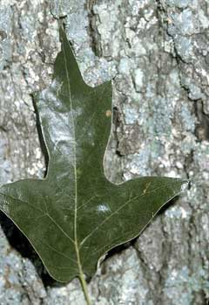
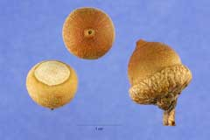
Southern red oak, also known as Spanish oak, is a medium to large deciduous oak that typically matures to 60-80’ tall. This is an ornamentally attractive oak with a straight trunk and an open rounded crown. Leaves (typically 4-9” long) are variable on the same tree (obovate to broad oval with 3 to 9 pointed bristle-tipped lobes and rounded bases). Leaves are dark green above and pale green below. Leaves remain on the tree late into fall with insignificant reddish brown fall color. Smooth bark becomes dark and furrowed with age. Insignificant monoecious flowers appear in spring in male catkins (yellowish green) and in female clusters (red tinged). Fruits are small globular acorns (to 1/2” long). Acorns appear in September-October. Falcata means sickle-shaped, in reference to the appearance of the leaf lobes
Callicarpa americana
Common Name | American Beautyberry, Beautyberry, French Mulberry
Family | Verbenaceae
Type | Deciduous shrub
USDA hardiness | 6-10
Height | 3-6 ft.
Bloom time | June to August
Bloom description | Lavender, pink. Insignificant.
Habitats | Rich woods and thickets.
Native Range | South-eastern N. America - Florida to Texas and north to Oklahoma and Arkansas.

Callicarpa americana is a loose open shrub valued for its spectacular fruits. The relatively insignificant flowers develop into prolific bright violet to magenta berry-like drupes, which encircle the stem. These fruits remain attractive for a long time although they are generally gone before severe winter weather. Genus name comes from Greek meaning beautiful fruit.
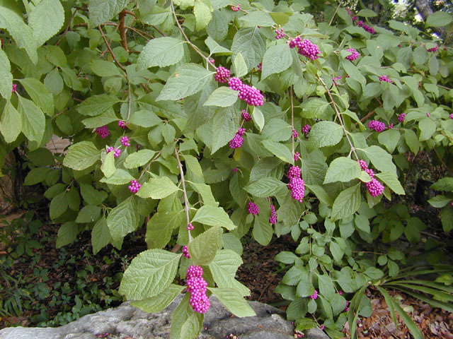
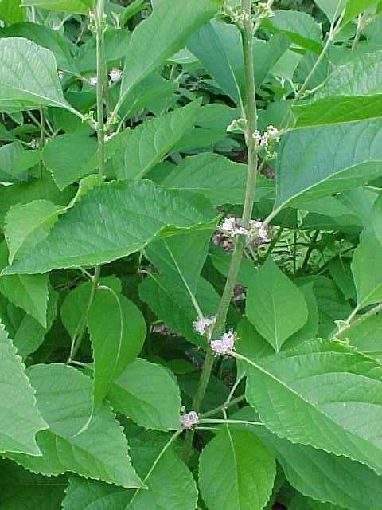
Calycanthus floridus
Common Name | Carolina Allspice, Eastern sweetshrub, Strawberry Bush, Sweetshrub, Carolina Allspice
Family | Calycanthaceae
Type | Deciduous shrub
Height | 6-10 ft.
Bloom time | April to July
Bloom Description | Brown; fragrant; showy
USDA hardiness | 5-10
Habitats | Rich low shady woodlands. Deciduous or mixed woodlands, along streams and rivers, margins of woodlands from sea level 6000 ft.
Native Range | South-eastern N. America - Virginia to Florida, west to Alberta and West Virginia.
Calycanthus floridus, commonly called Carolina allspice, is a dense, rounded deciduous shrub with a suckering habit which grows 6-9' tall with an equal or slightly greater spread. Features very fragrant, brown to reddish-brown flowers (2" across) which bloom at the ends of short branchlets in May. Flowers give way to brownish, urn-shaped fruits (seed capsules) which mature in fall and persist throughout the winter. Lustrous, dark green (pale beneath), ovate to elliptic leaves to 6" long turn golden yellow in fall. Leaves are aromatic when bruised. Also commonly called sweetshrub and strawberry bush in reference to the fragrant blooms which have been described as combining hints of pineapple, strawberry and banana. Genus name comes from the Greek words kalyx meaning calyx and anthos meaning a flower.
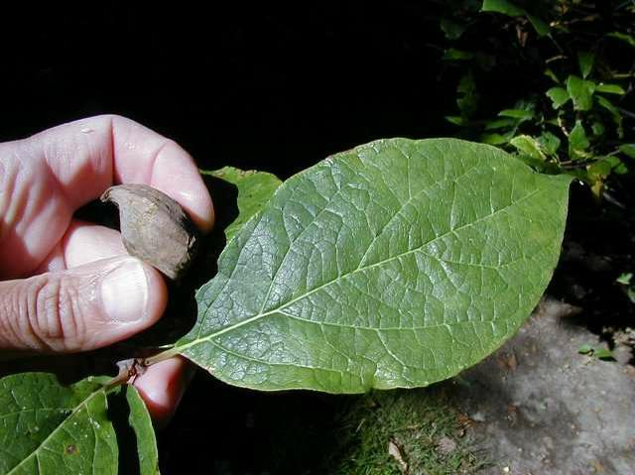
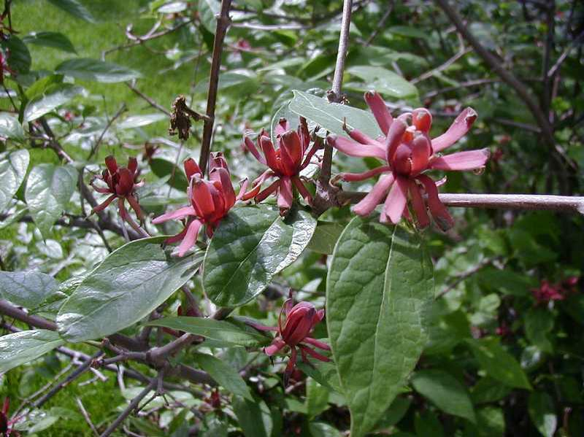
Fothergilla major
Common Name | Witch-alder, large fothergilla, tall fothergilla, mountain witch alder
Family | Hamamelidaceae
Type | Deciduous shrub
Height | 6-10 ft.
Bloom time | April to May
Bloom Description | White; fragrant; showy
USDA hardiness | 4-8
Habitats | Sunny, wet edges of shrub swamps, Atlantic white cedar forests, Carolina bays, pitcherplant bogs, and shrubby edges of wet flatwoods.
Native Range | Southeastern US: Appalachians in North Carolina, Georgia and Alabama
Fothergilla major is a member of the same family as witch hazel (Hamamelis). It is native to the southeastern U.S., primarily in mountain woods, ravines and along stream banks in the southern. It is a slow-growing, deciduous shrub that grows 6-10’ tall with an upright spreading habit. It is noted for its aromatic spring flowers, quality summer foliage, excellent fall color and excellent disease resistance. Terminal, bottlebrush-like spikes (1-3” long) of tiny, fragrant, apetalous, white flowers bloom in spring (April-early May) after the foliage emerges. Ovate to obovate dark green leaves (2-4” long) are leathery above and blue-gray beneath. Leaves are typically toothed in the upper 2/3 of the leaf. Foliage turns excellent shades of yellow, orange and red-purple in fall. Fruit is a non-ornamental, beaked, egg-shaped two-seeded capsule (to 1/2” long) which matures in fall, eventually bursting and explosively broadcasting the seed. Genus name honors John Fothergill (1712-1780), an 18th century Quaker physician from Essex, United Kingdom who was an early collector of American plants.
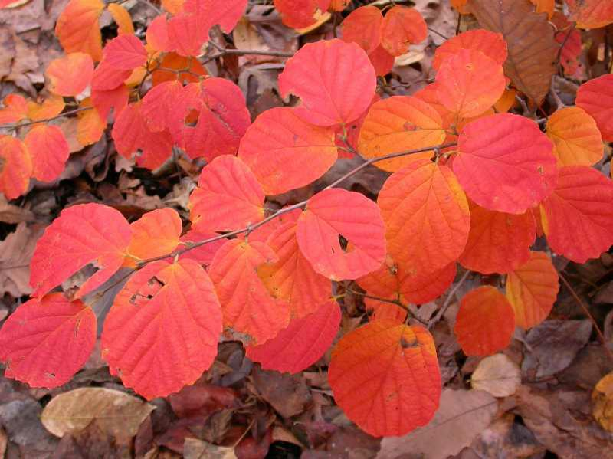
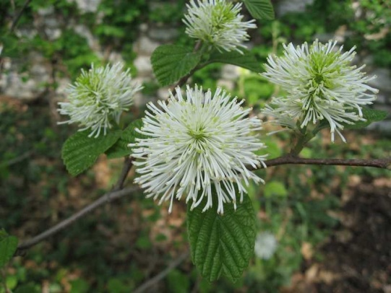
Hydrangea quercifolia
Common Name | Oakleaf hydrangea
Family | Hydrangeaceae
Type | Deciduous shrub
Height | 6-8 ft.
Bloom time | May to July
Bloom Description | White changing to purplish pink; showy
USDA hardiness | 5-9
Habitats | Damp woods; riverbanks
Native Range | Southeastern United States
Hydrangea quercifolia, commonly called oak leaf hydrangea, is an upright, broad-rounded, suckering, multi-stemmed, deciduous shrub that typically grows 4-6' (less frequently to 8') tall. It is native to bluffs, moist woods, ravines and stream banks from Georgia to Florida to Louisiana. It is noted for producing pyramidal panicles of white flowers in summer on exfoliating branches clad with large, 3-7 lobed, oak-like, dark green leaves. Genus name comes from hydor meaning water and aggeion meaning ‘vessel’, in reference to the cup-like capsular fruit. Specific epithet is in reference to the leaves that look like those of Quercus (oak).
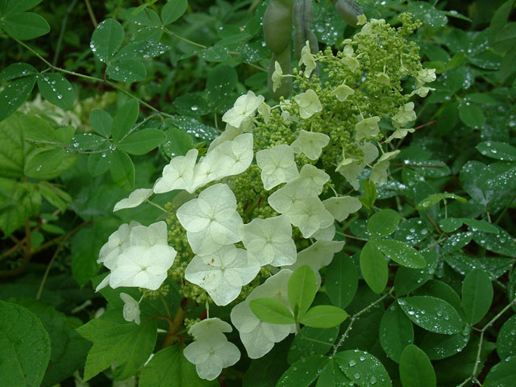
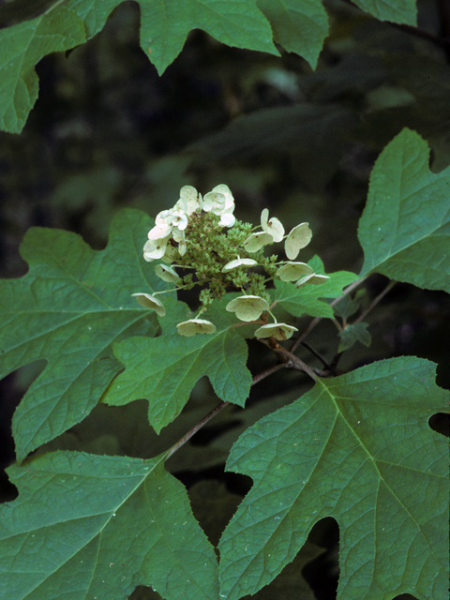
Itea virginica
Common Name | Virginia Sweetspire
Family | Iteaceae
Type | Deciduous shrub
Height | 3-5 ft.
Bloom time | June to July
Bloom Description | White; showy
USDA hardiness | 5-9
Habitats | Swamps, low wet woods and along spring branches
Native Range | Eastern North America
Virginia sweetspire is an erect, rounded, deciduous shrub which typically grows 3-5' tall in cultivation (to 10' in the wild). Features fragrant, tiny white flowers borne in cylindrical, drooping racemes (2-5" long) which cover the shrub with bloom in early summer. Oval, dark green leaves (1-4" long) turn an attractive red in autumn, sometimes persisting on the shrub until December.
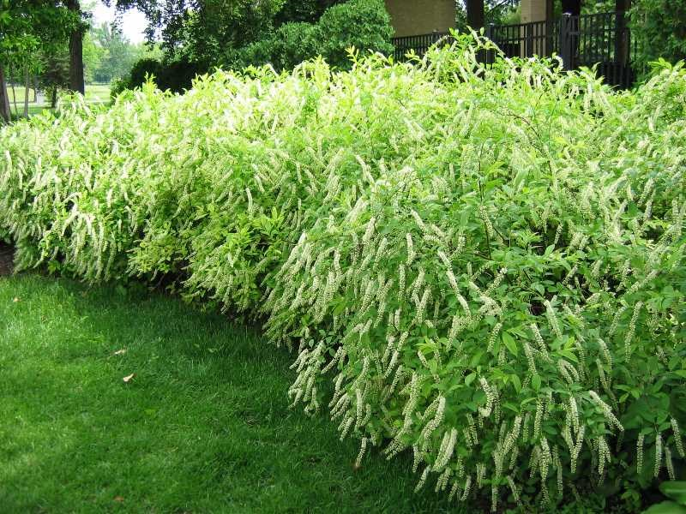
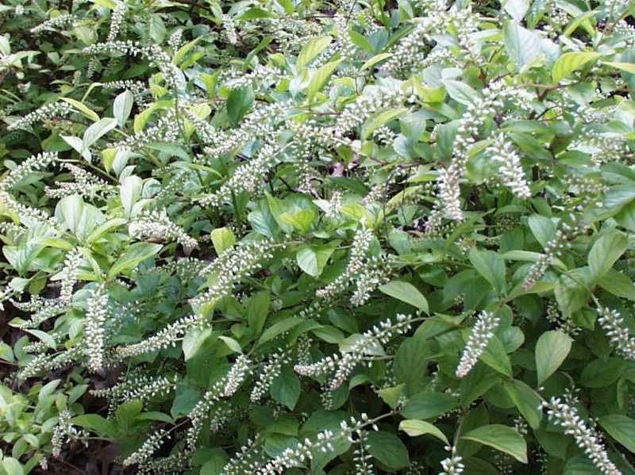

Leucothoe fontanesiana

Common Name | Fetterbush; dog hobble; drooping laurel
Family | Ericaceae
Type | Evergreen shrub
Height | 3-6 ft.
Bloom time | May
Bloom Description | Small white, urn-shaped in 2-3" long racemes
USDA hardiness | 6-8
Habitats | Cool, shady ravines along streams
Range | Mountainous regions of southeastern U.S.
Leucothoe fontanesiana is a suckering, multi-stemmed, broadleaf evergreen shrub with arching branches that is native to moist forested mountain areas, dense thickets, stream banks and ravines from New York south to Alabama and Georgia, primarily in the Appalachian Mountains. It typically grows in a mound to 3-6' tall and as wide. Drooping spikes of waxy, urn-shaped, creamy white flowers droop from the leaf axils in spring (May). Leathery, lanceolate, evergreen leaves (to 5" long) have serrulate margins and taper to a long point. Long, pointed, dark-green, glossy foliage turns red-green and purple in winter. New growth is often quite red.
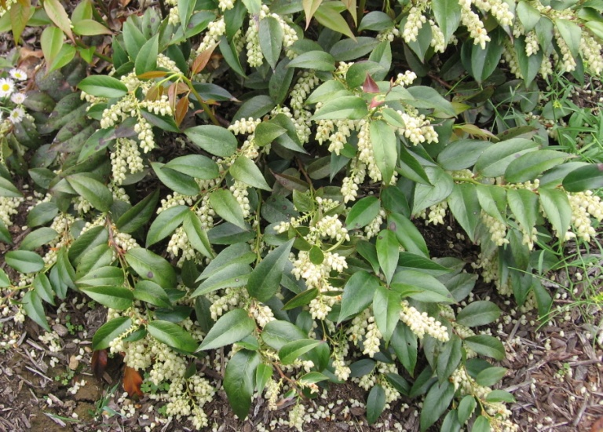
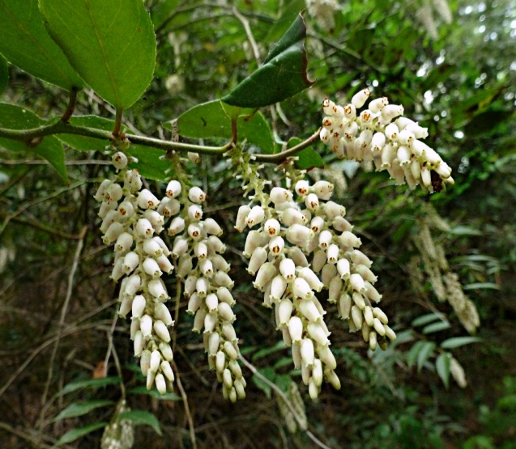

Morella cerifera
Common Name | Wax myrtle , Southern wax myrtle, Southern bayberry, Eastern bayberry, Bayberry, Candleberry, Tallow shrub
Family | Myricaceae
Type | Evergreen shrub
Height | 6-12 ft.
Bloom time | Early spring
Bloom Description | Inconspicuous
USDA hardiness | 7-11
Habitats | Moist forest; marshes; fresh to slightly brackish stream banks; swamps
Range | New Jersey west to southeast Oklahoma and east Texas, south through Florida.
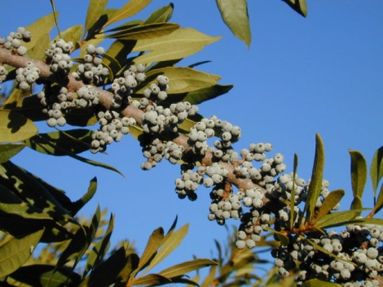
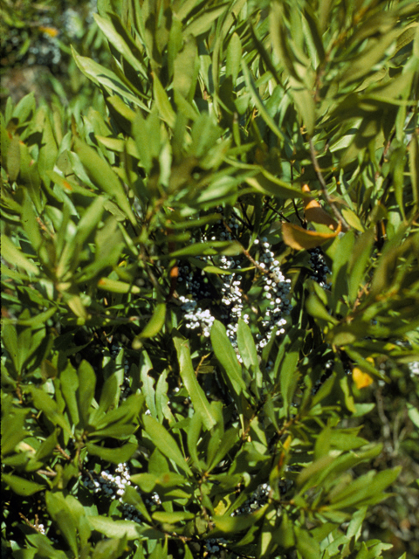
A wispy, 6-12 ft., multi-trunked, evergreen shrub, southern bayberry or wax myrtle can reach 20 ft. in height. The light olive-green foliage has a spicy fragrance. Pale blue berries occur on female plants in the winter. Waxmyrtle plants are either male or female. Only female plants bear berries. Handsome gray bark is almost white on some plants. The leaves are aromatic, with an appealing, piquant fragrance when crushed. Colonists separated the fruit’s waxy covering in boiling water to make fragrant-burning candles, a custom still followed in some countries. Attractive to birds and butterflies, it is the larval host for the Red-Banded Hairstreak butterfly.
